**Project Design Phase-II**

**Technology Stack (Architecture & Stack)**

|  |  |
| --- | --- |
| Date | 03 October 2022 |
| Team ID | PNT2022TMID50730 |
| Project Name | Web phishing Detection |
| Maximum Marks | 4 Marks |

**Technical Architecture:**

**Web phishing Detection**

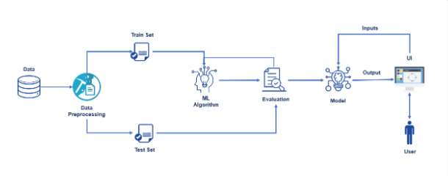

**Table-1 : Components & Technologies:**

|  |  |  |  |
| --- | --- | --- | --- |
| **S.No** | **Component** | **Description** | **Technology** |
|  | User Interface | How user interacts with application e.g.  Web UI, Mobile App, Chatbot etc. | HTML, CSS, JavaScript |
|  | Application Logic-1 | Upload the dataset | Python |
|  | Application Logic-2 | Extract lexical features | Python |
|  | Application Logic-3 | User give the input | Python |
|  | Database | Data Type, Configurations etc. | MySQL |
|  | Cloud Database | Database Service on Cloud | IBM DB2, IBM Cloudant etc. |
| 7 | File Storage | File storage requirements | IBM Block Storage or Other Storage Service or Local Filesystem |
| 8 | Machine Learning Model | Purpose of Machine Learning Model | Classification Model |

**Table-2: Application Characteristics:**

| **S.No** | **Characteristics** | **Description** | **Technology** |
| --- | --- | --- | --- |
|  | Open-Source Frameworks | List the open-source frameworks used | Technology of Opensource framework |
|  | Security Implementations | Use anti-phishing protection and anti-spam software to protect yourself when malicious messages slip through to your computer. | Technology used |
|  | Scalable Architecture | Justify the scalability of architecture | Technology used |
|  | Availability | Justify the availability of application | Technology used |